Manual Test Plan

# Environment

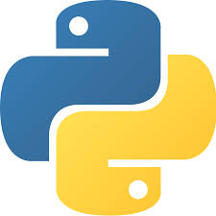

Install the latest version of PyCharm

Install Python 3.6+

## Modules

In order for the scraping to work, make sure to install the following modules:

* JSON
* MongoDB Atlas
* BeautifulSoup
* Requests

## Code Base

Download the code package from Gitlab, and make sure the following files appear:

* Author_scraper.py
* Book_scraper.py
* Test.py
* [books.json]
* [authors.json]

The JSON files may or may not appear based on if the scrapers have been run in the past.

# Running Scraper:

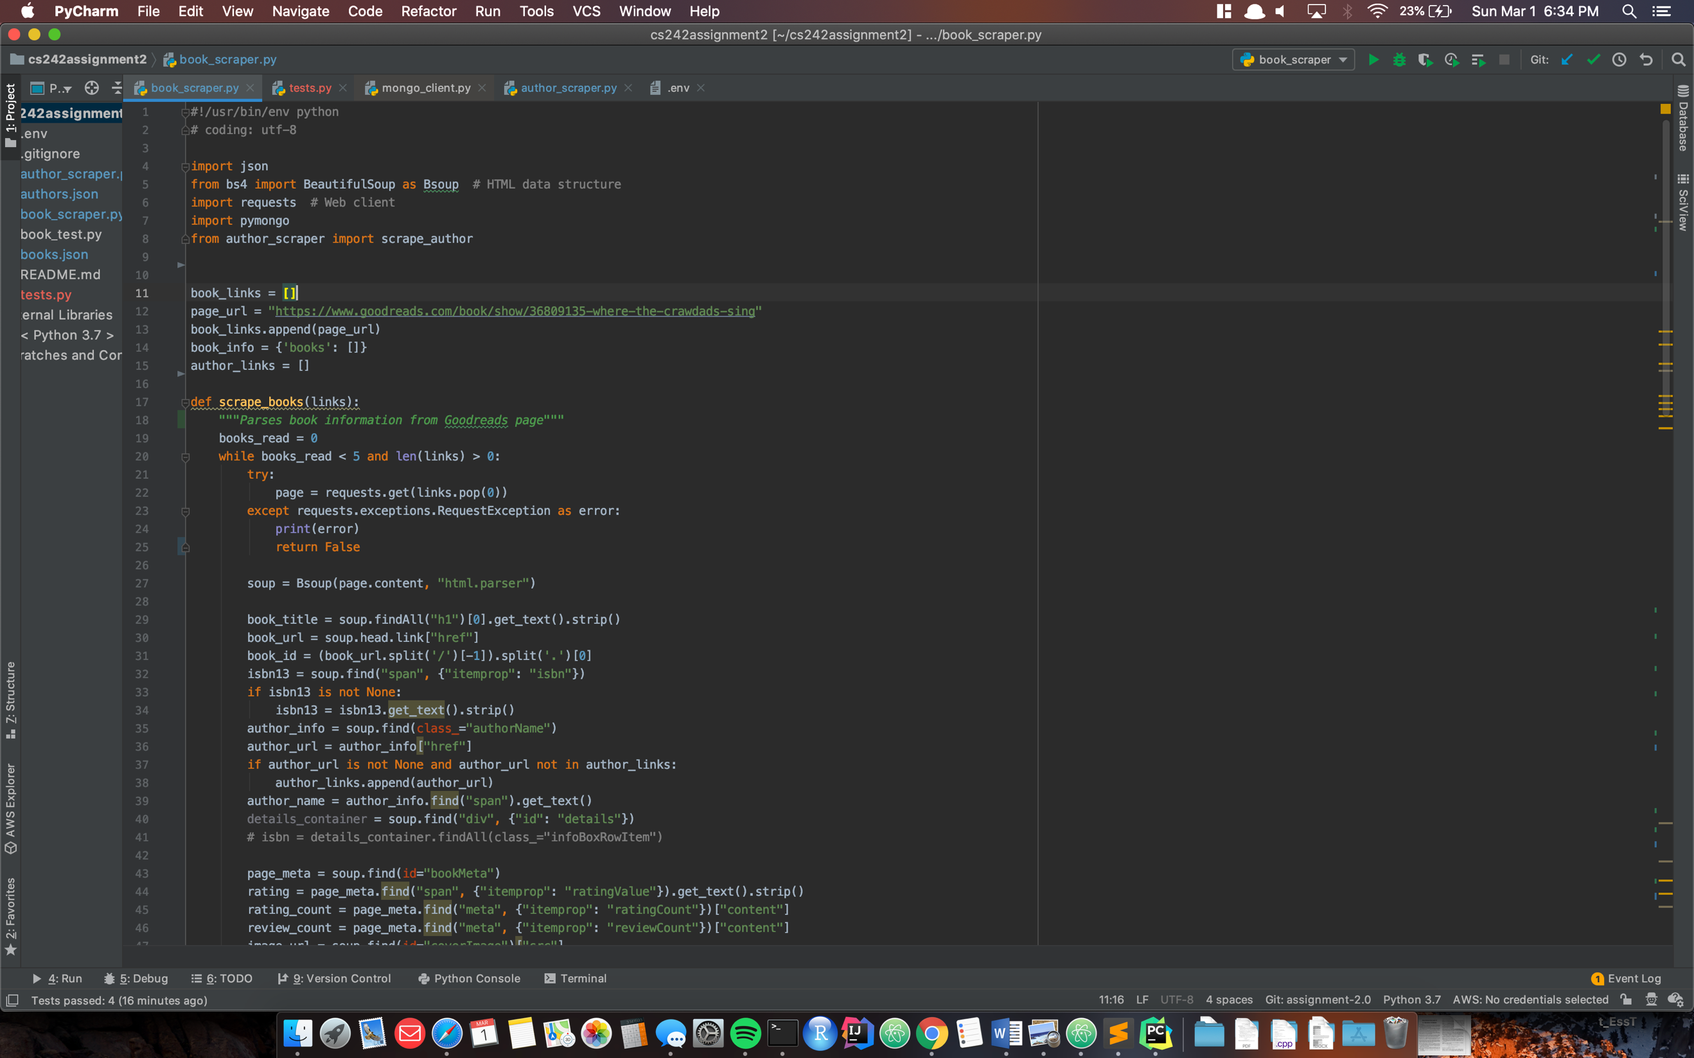

Set the configuration to be run in PyCharm to book_scraper and click the green play button

# Output to JSON:

Books.json:

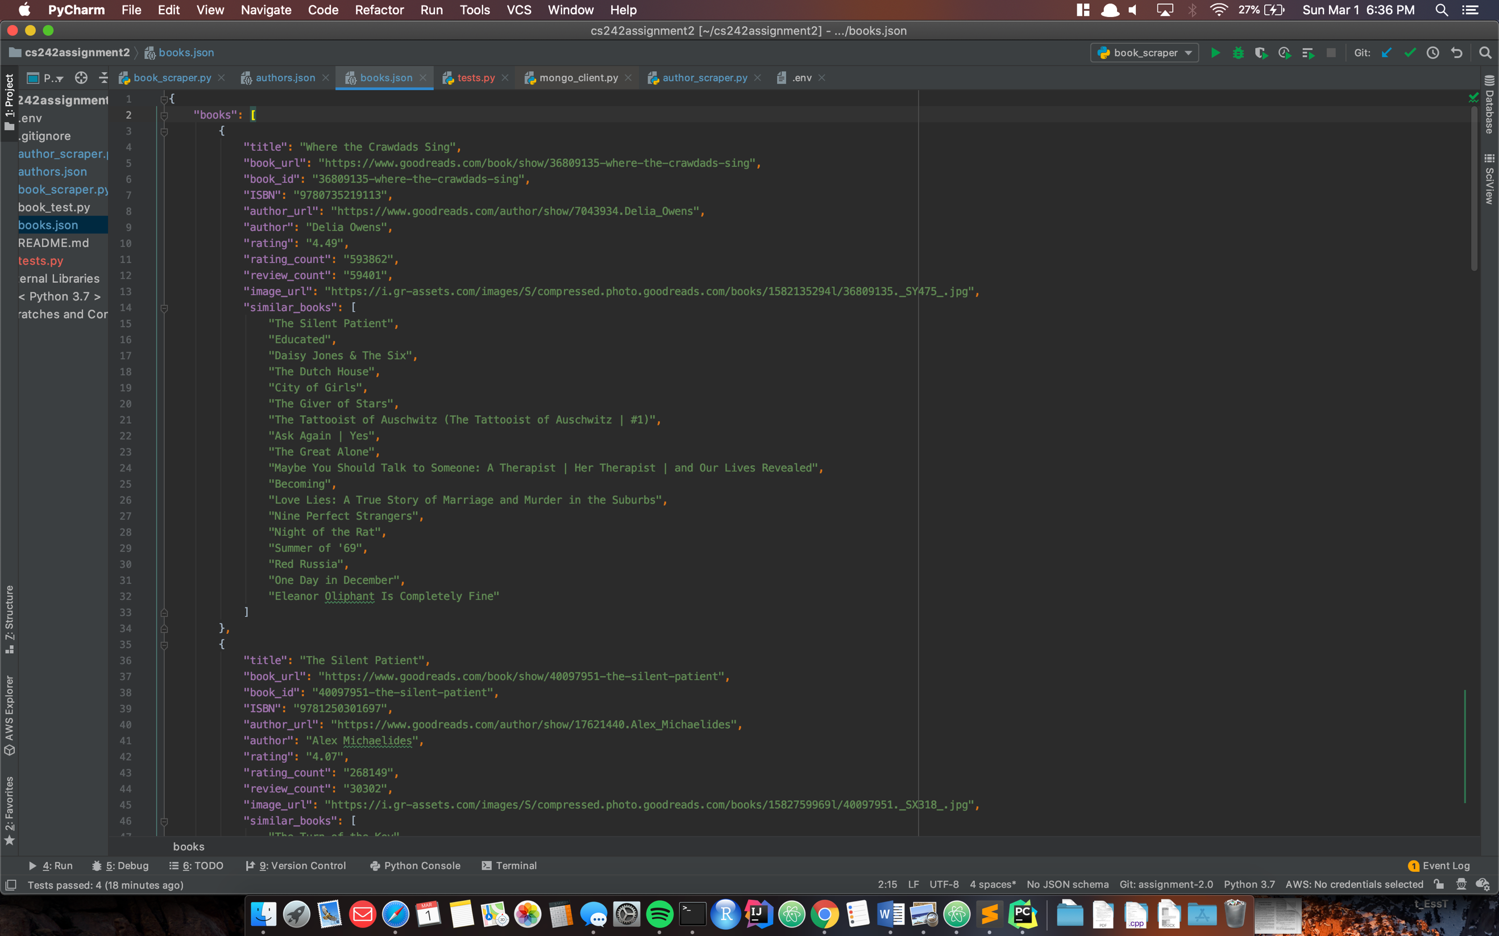

Authors.json:

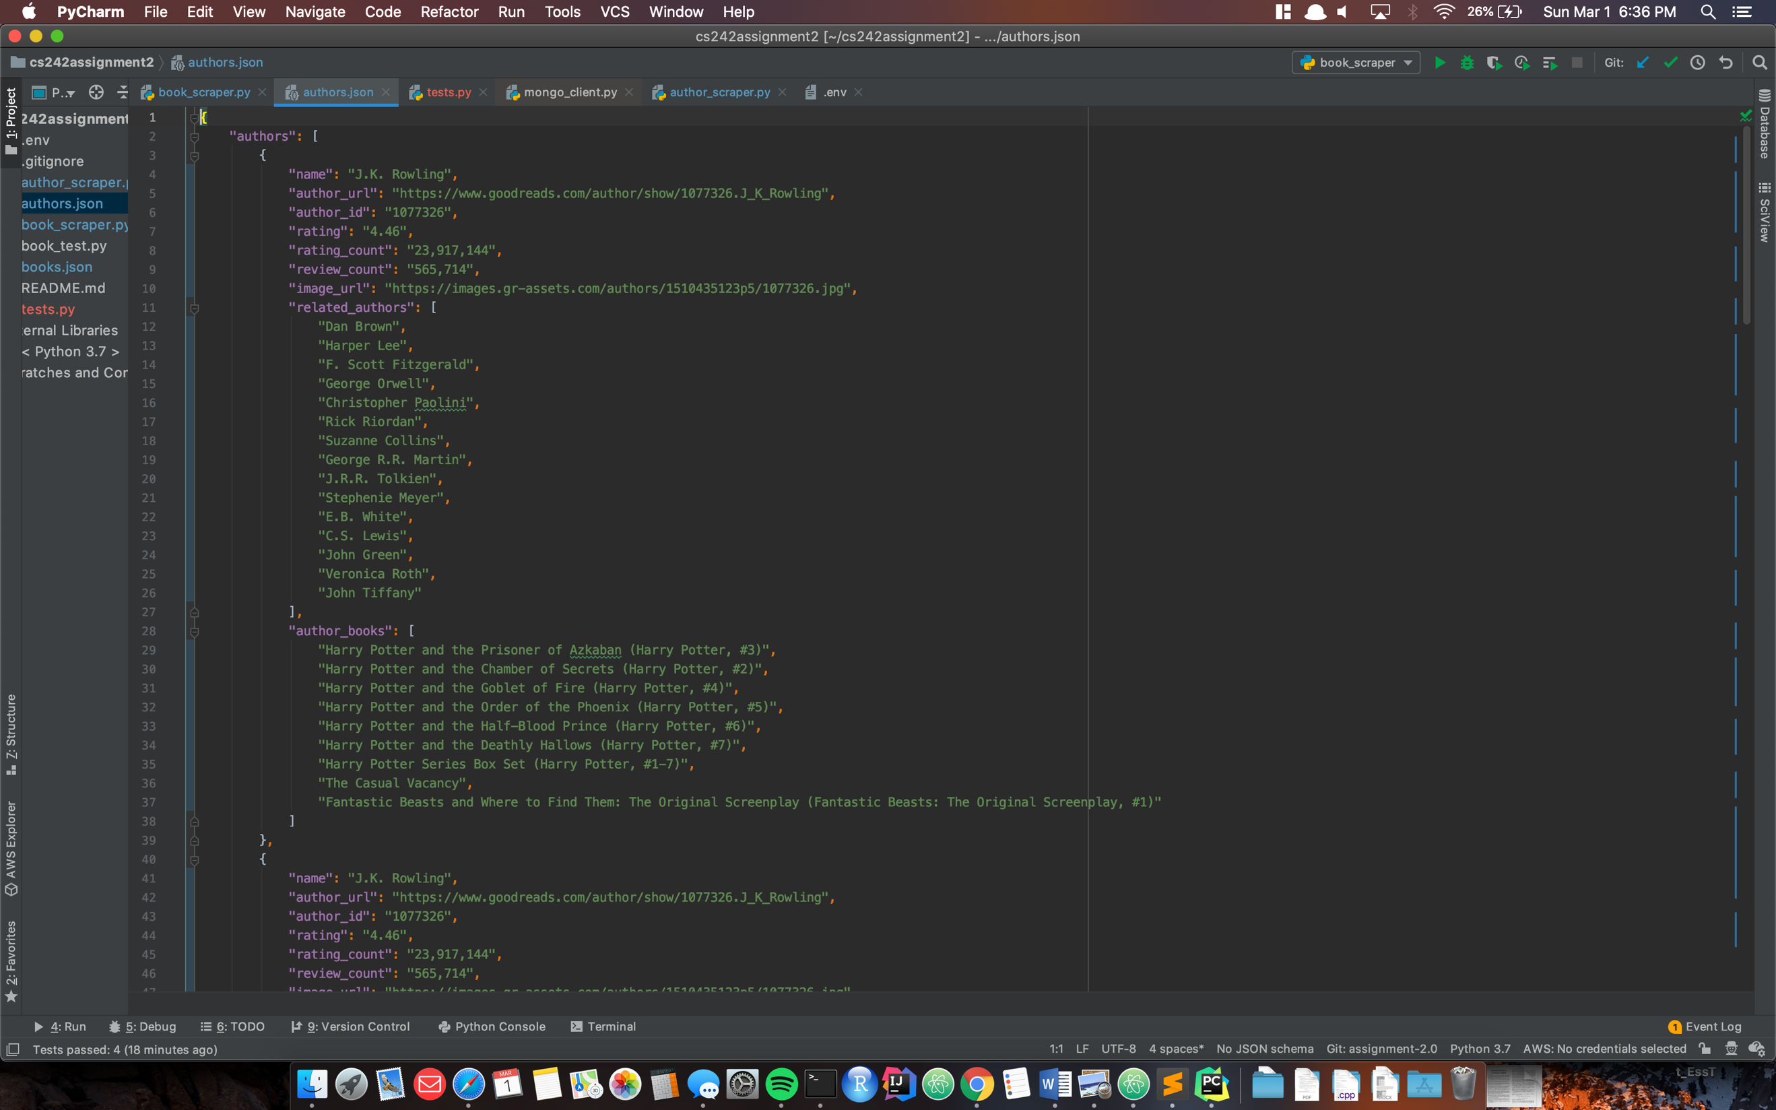

1. Open the JSON files that have been outputted.
2. Ensure that the structure of the files are as follows:

Book:

|  |  |
| --- | --- |
| book_url | URL of the Book |
| title | Name of the Book |
| book_id | A unique identifier of the book |
| ISBN | the ISBN of the book |
| author_url | URL of the author of the book |
| author | Author of the book |
| rating | the rating of the book |
| rating_count | the number of rating the book received |
| review_count | the number of comments the book received |
| image_url | A URL of the book's image |
| similiar_books | A list of books similar or related to the book |

Author:

|  |  |
| --- | --- |
| name | Name of the Author |
| author_url | the page URL |
| author_id | a unique identifier of the author |
| rating | the rating of the author |
| rating_count | the number of rating the author received |
| review_count | the number of comments the author received |
| image_url | A URL of the Author's image |
| related_authors | A list of Author related to the author |
| author_books | A list of books by the author |

# MongoDB Atlas Setup

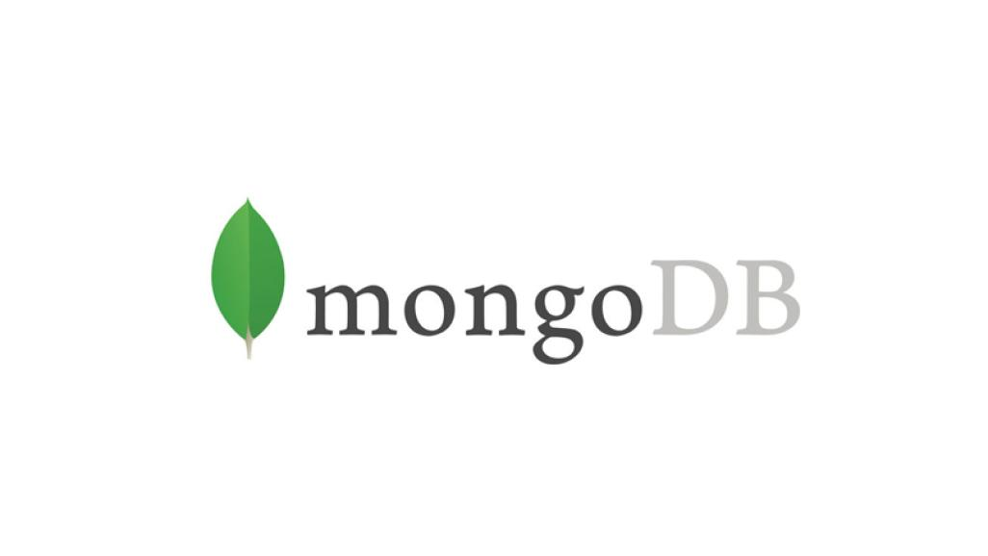

In order to set up the mongoDB database, create an free shared cluster account.

On the home page:

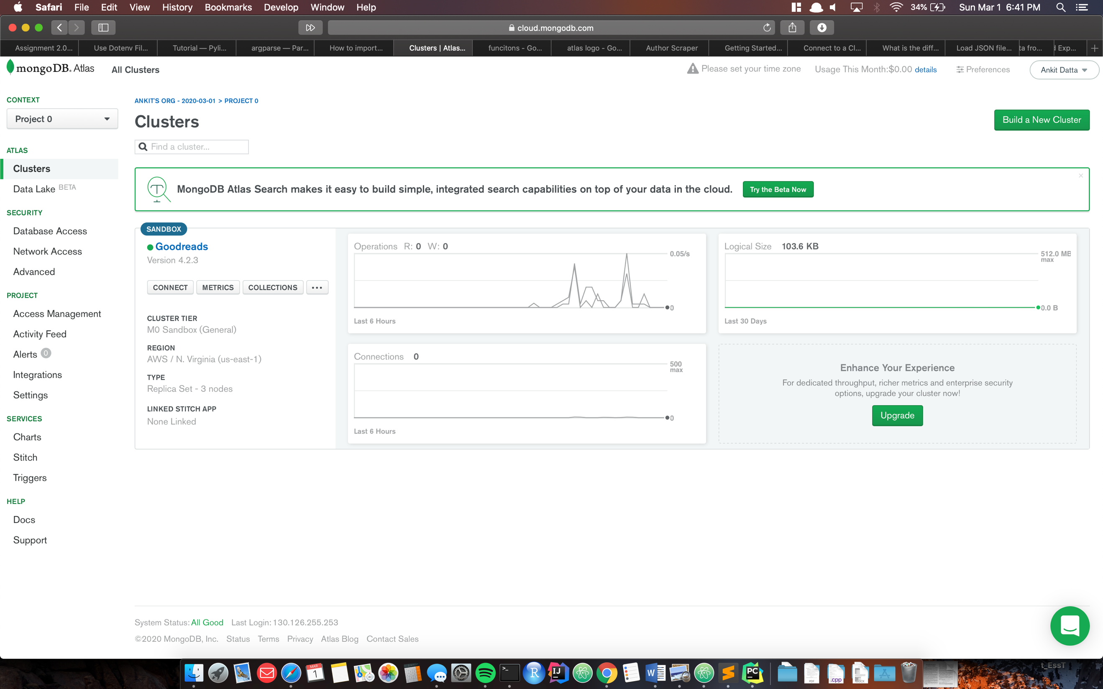

Click on Connect:

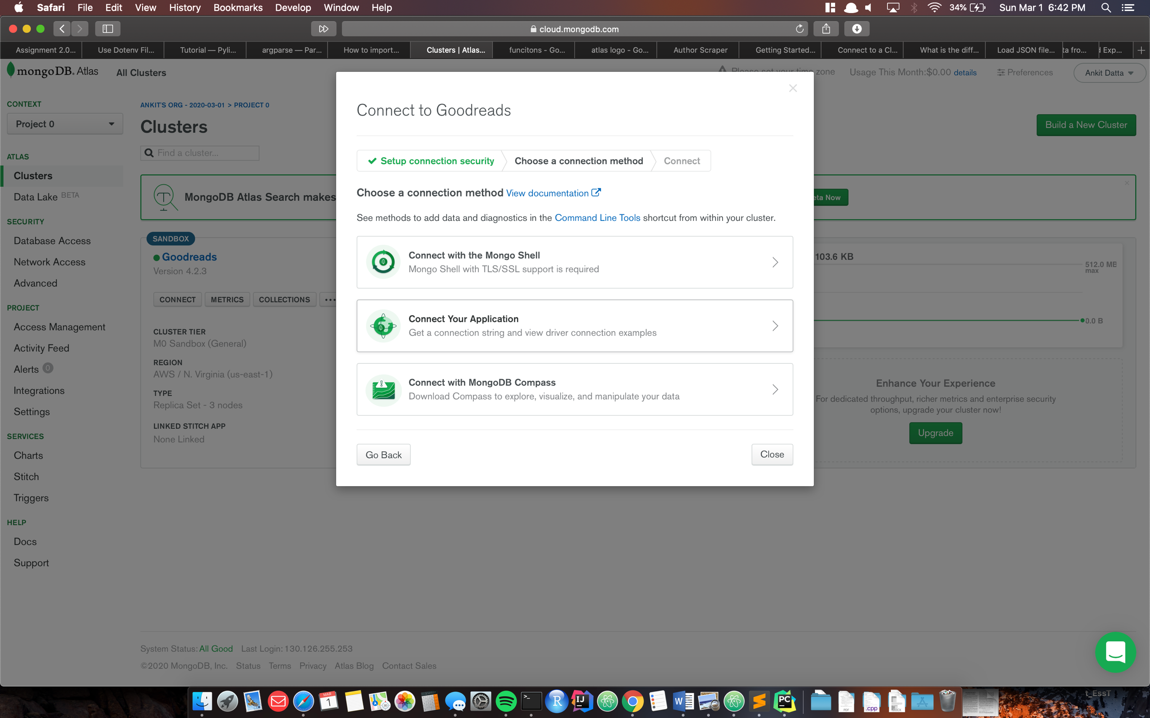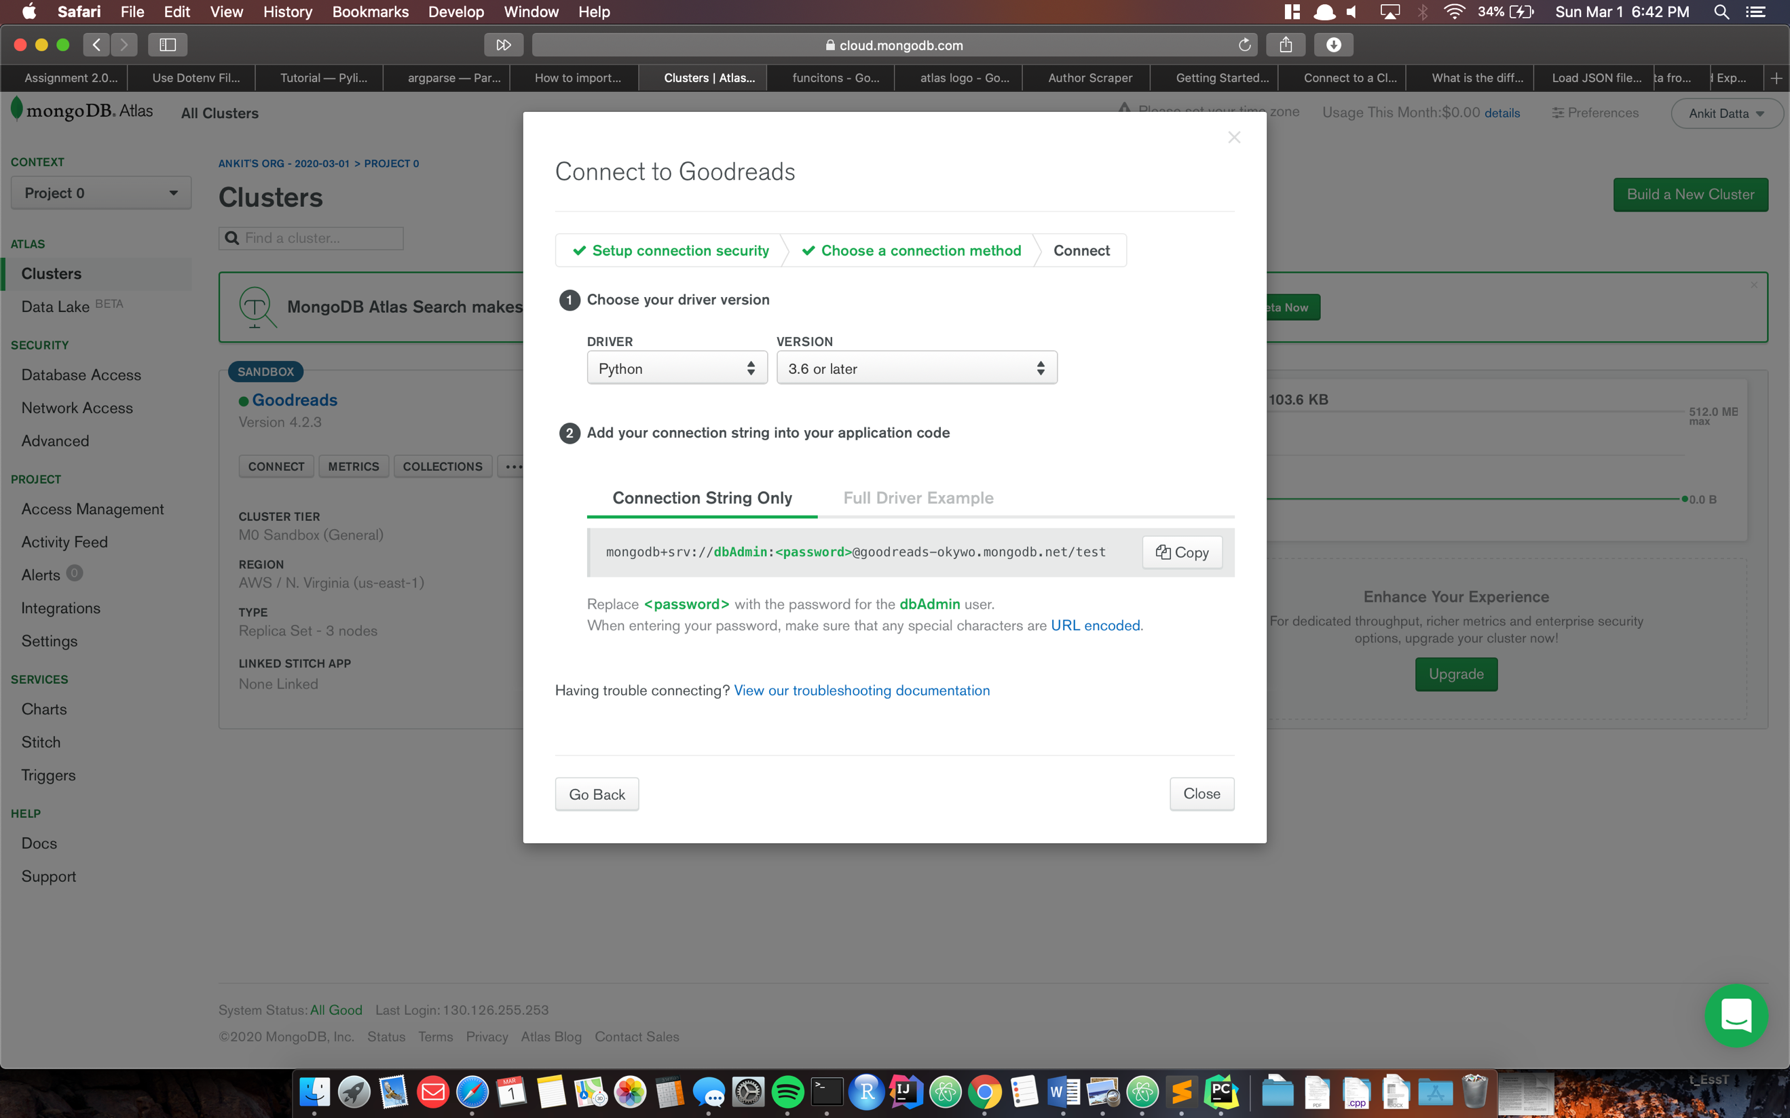

Make sure Python is selected as the language to connect to the database.

# Storing data to mongoDB

Once the scraper is run, it should automatically store the information found on Goodreads into the mongoDB database.

The following collections should appear:

Books and authors:

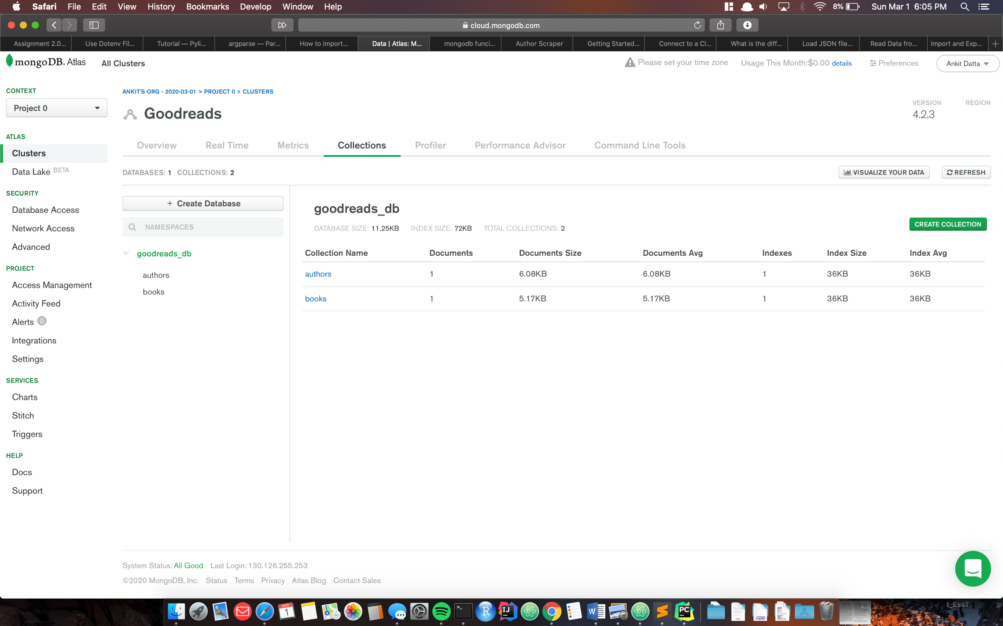

# Authors Collection:

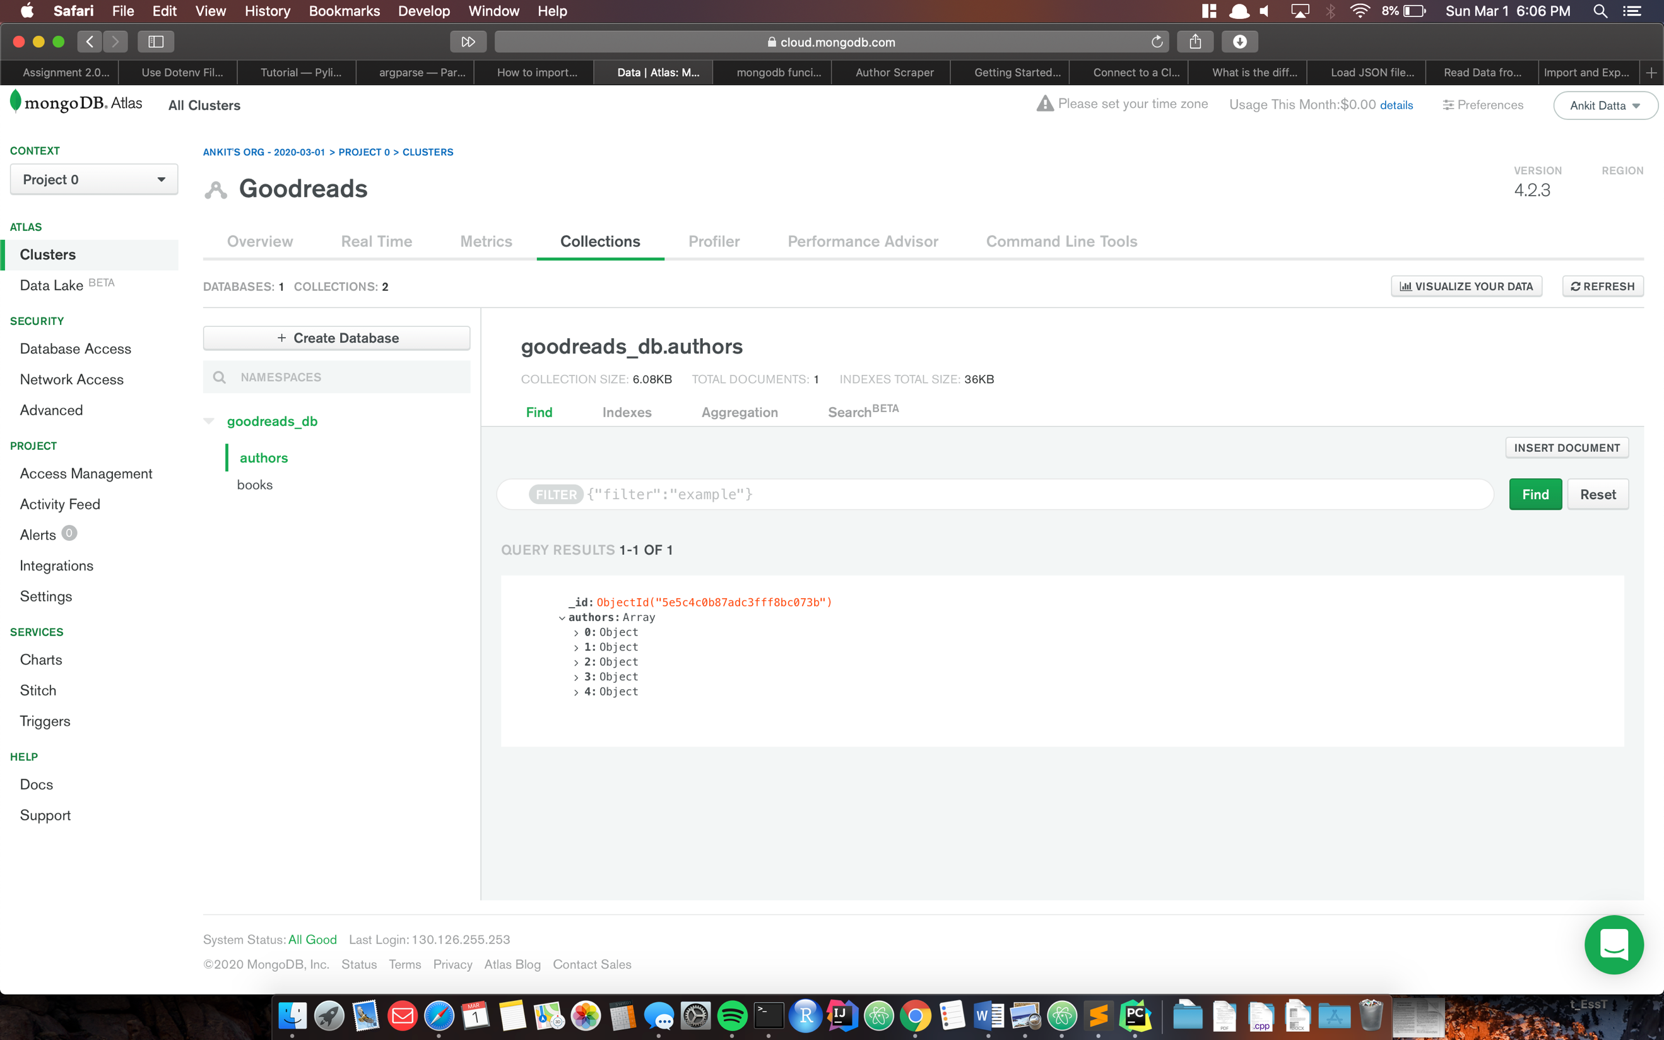

Expand the list to view the full information:

For our sample run with 5 authors, ensure that the list has 5 elements.

Expand each index and verify that the data stored is the same format and contains the same information as the JSON file.

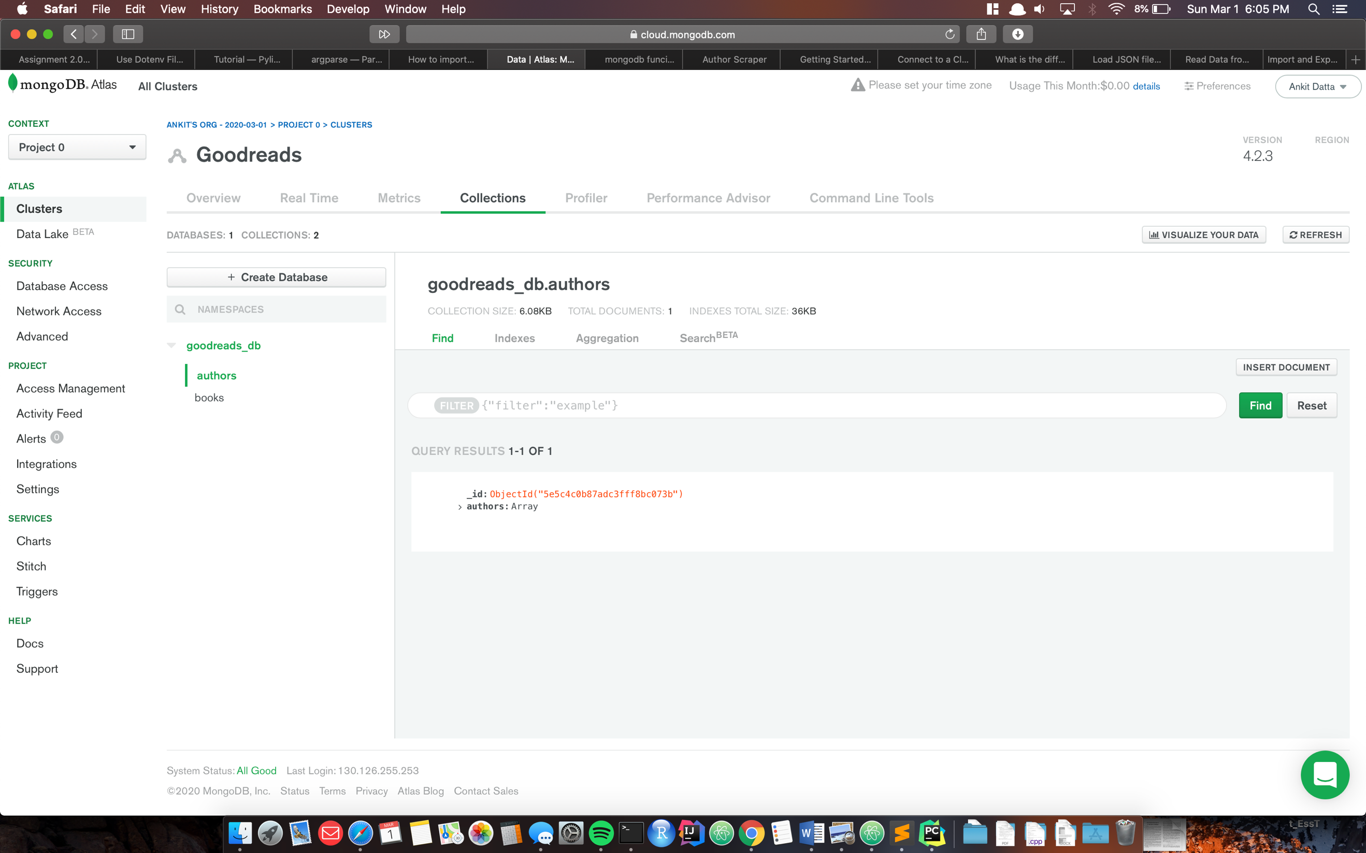

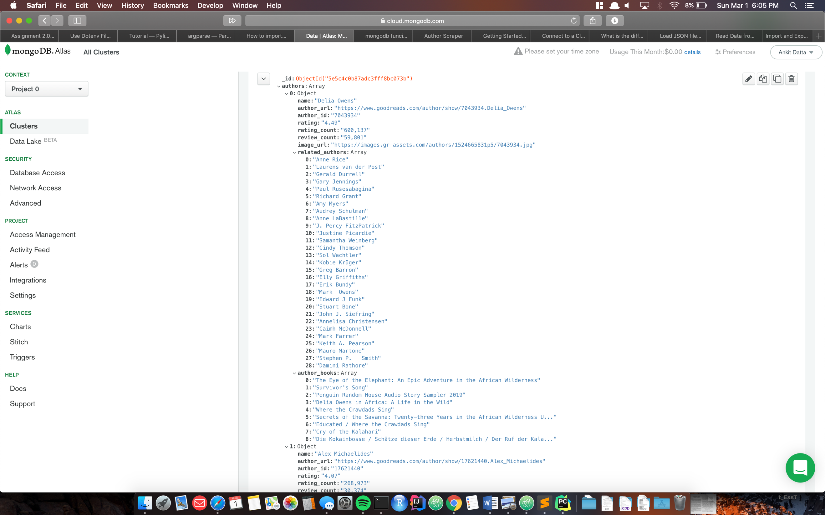



# Books Collection:

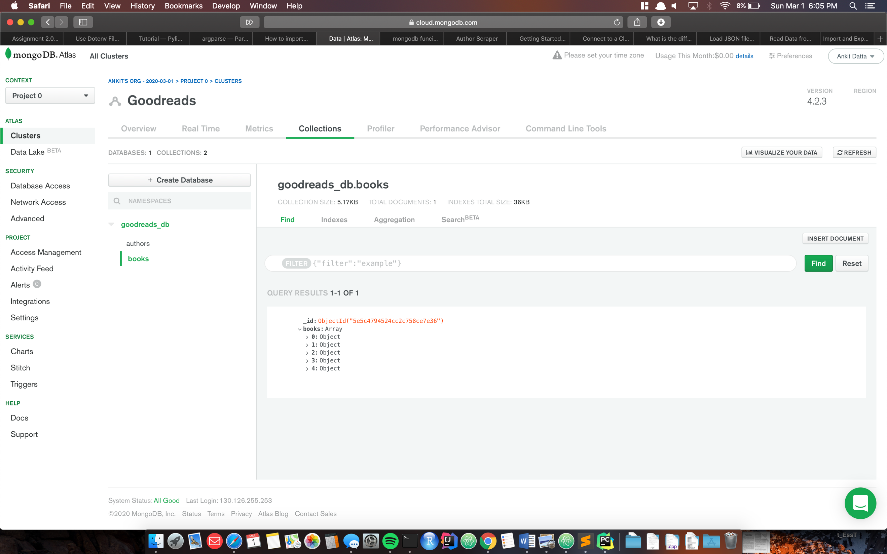

Follow the same pattern for the books collection:

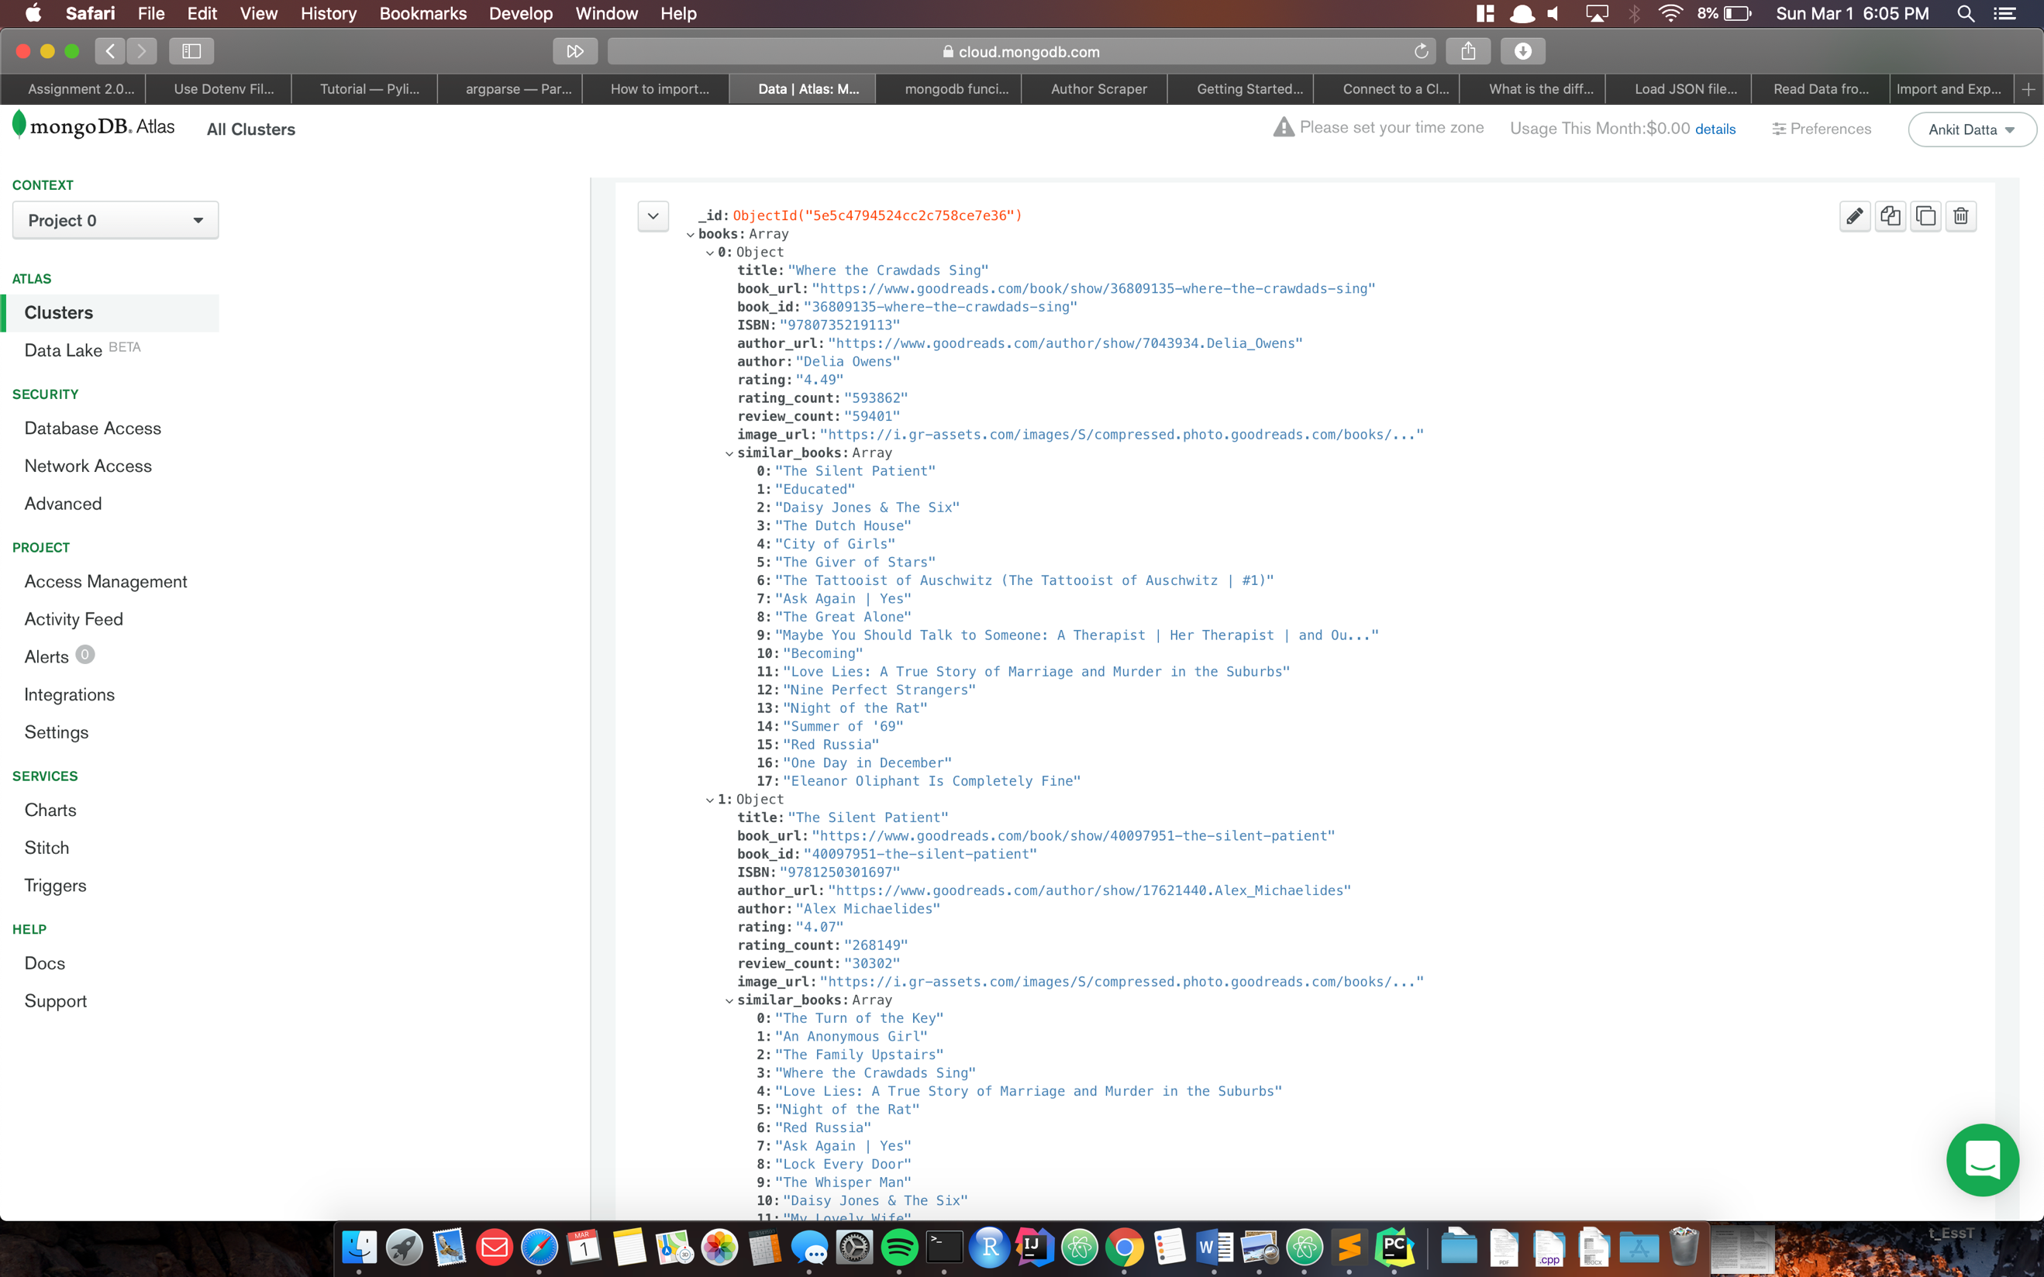

# Unit Testing:

Run the unit tests in tests.py to ensure that they all run.